

*Neural networks fınal exam report*

PREPARED BY

NAME&SURNAME : Sedat aydıncık

STUDENT NUMBER : 040180076

DATE : 15/01/2024

COURSE : artıfıcıal neural networks

course ınstructor : asst. prof. onur ergen

1. data collectıon

My friend Eren Kuş, whom I took this course with simultaneously, and I prepared this dataset together. We obtained data collaboratively, including determining the area for iterations, identifying the point of coin toss and the origin, and measuring the distances from the point where the coin fell to the origin.105 iterations of coin drop from a height of 1 meter captured and utilized with images. These images are representing the landing result and distance from selected origin. Iterations are classified as: Heads facing up, Tails facing up and Vertical drop and each of classifications has 35 iterations equally. Result classes are Heads or Tails for landed coin and the distance from origin point predefined of each one of iteration in centimeters. My friend and I prepared this environment and we measured each of the iteration colobratively.

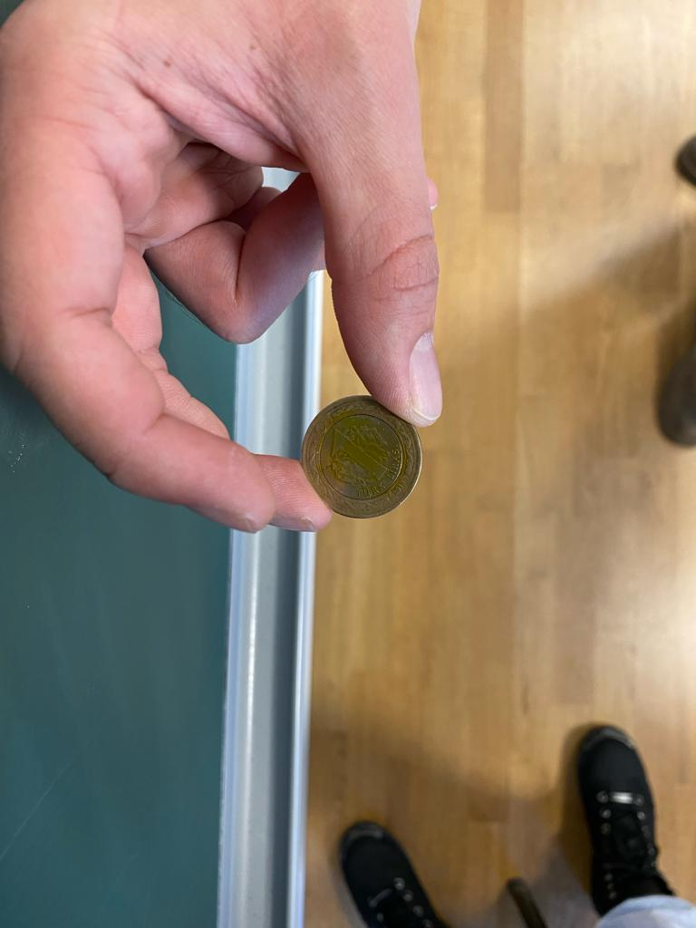

Figure 1-Tails Facing Up dropping

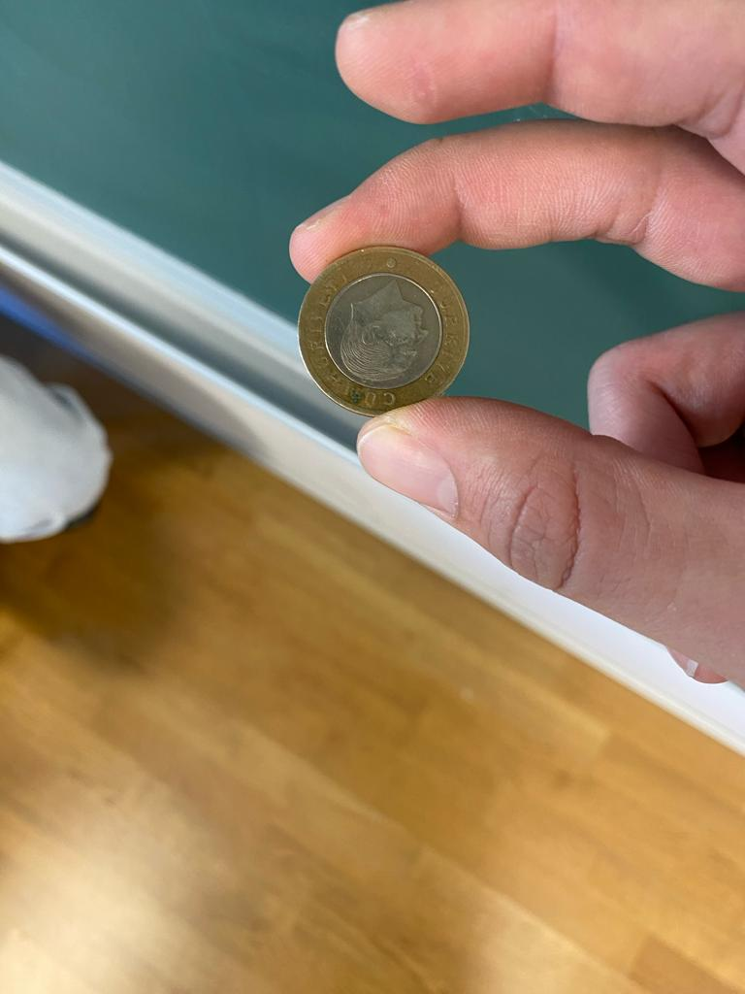

Figure 2-Heads Facing Up dropping



Figure 3-Vertical dropping

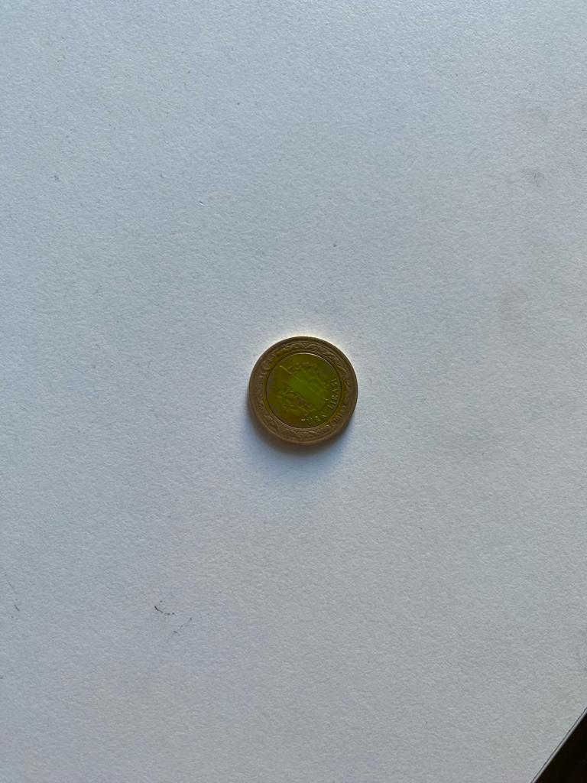

Figure 4-Tails

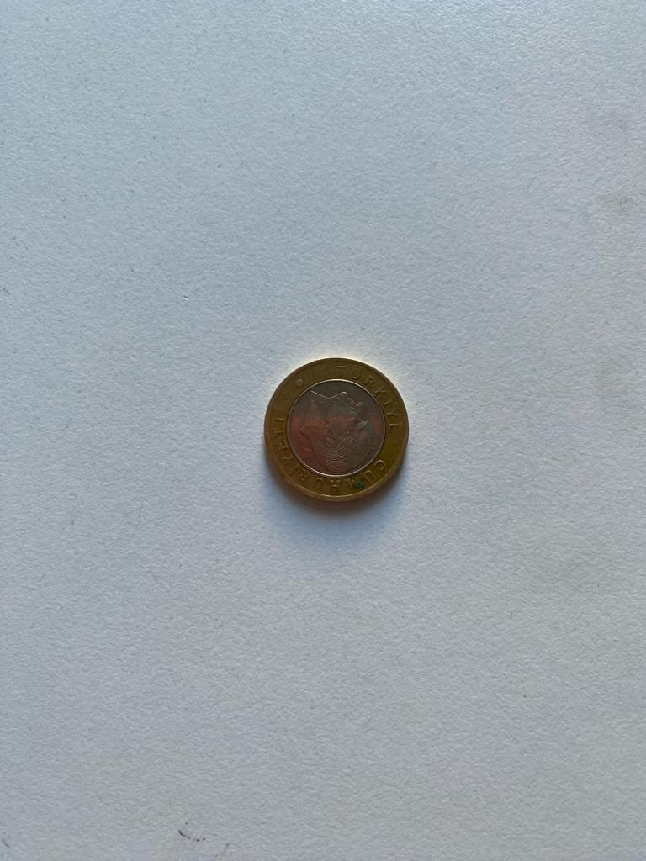

Figure 5-Tails

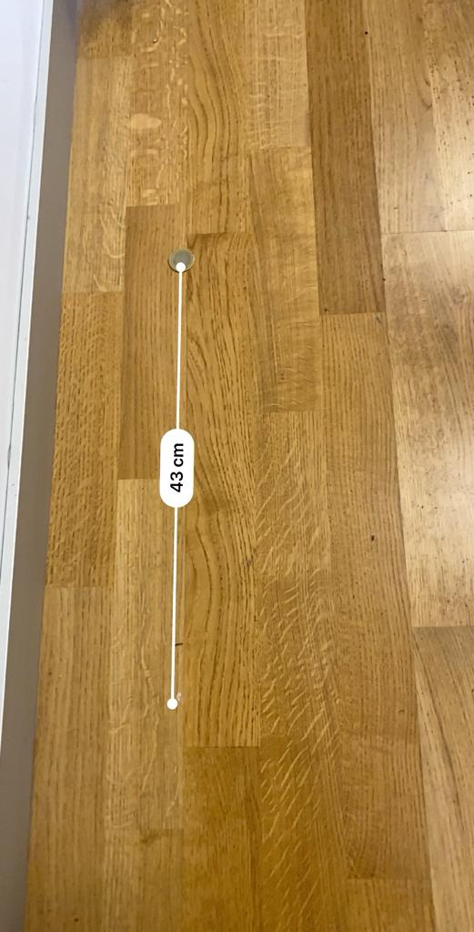

Figure 6-Distance from origin example

2. data labelıng

These iterations classified as three different labels: Heads facing up, Tails facing up and Vertical drops. Result labels are: Heads and Tails. The distance is given in centimeter and label is: Landed Coin.

3. preprocessıng

The surface where we tossed the coin was wooden, and all iterations were conducted on the same wooden surface. The projection of the determined 1-meter height on the ground was accepted as the origin, and the distance of the fallen coins from the origin was estimated and measured using a phone. The measurement for each iteration was recorded. The coin was released in three different orientations, and while obtaining the expected two different outcomes, the results were recorded for each iteration.

4. Model selectıon

Model for classification selected “Random Forest Classifier”. Dataset is divided as training and testing sets and testing sets are %20 of the total dataset is defined.

5. Model evaluatıon

Neural network’s performance parameter is accuracy and its calculated in code.

6. PREDICTION

For prediction, user input required for coin orientation while dropping. After the selection of orientation, prediction made by using selected classes datas. Distance from origin is average value of distance values.

7. CHALLENGES

The orientation of the coin released in free fall for data collection was significantly affected by factors such as hand tremors and the inability to consistently maintain the exact same position in each iteration, as we released the coin manually. The area where we released the coin was close to the wall, and in cases where the coin bounced towards the wall, the result was influenced by the coin bouncing off the wall. The distance of the coin from the predetermined origin was measured with the help of a phone, and although this measurement value is close to the true value, there is a margin of error.

In order to ensure the consistent orientation of the coin upon release and to have the same release pattern for each iteration, a mechanism could have been set up to release the coin from a specified height with the help of this device. By selecting an open area without obstacles for releasing the coin, situations that could alter the result, such as the coin bouncing off the wall, could have been avoided. The limitation in the number of iterations has negatively affected the accuracy of the data. Increasing the number of iterations could have led to achieving the targeted accuracy.